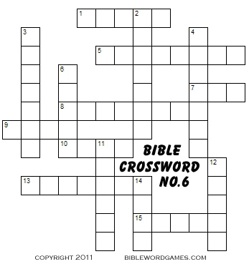

ACROSS
1 Noah found ___ in the eyes of the LORD.(Gen 6:8) KJV
5 God made a ___ with Noah after the flood (Gen.9:9)
7 Second son of Noah (Gen.7:13)
8 God caused the flood because the earth was filled with ____(Gen.6:13)
9 The last bird Noah sent out to search for dry land (Gen.8:10)
10 God asked ___ to build an ark (Gen.6:14)
13 Noah brought all the ___ into the ark two by two (Gen.6:20)
15 How many people were on board the ark? (Gen.7:13)
DOWN
2 The waters ___ all the mountains in the world (Gen.7:20)
3 God put a ___ in the clouds as a sign of no more floods (Gen.9:13)
4 Third son of Noah (Gen.7:13)
6 The first bird Noah sent out to search for dry land (Gen 8:7)
11 The ark came to rest on the mountains of ___ (Gen.8:4)
12 How many days did it rain during the flood? (Gen.7:17)
14 First son of Noah (Gen.7:13)

